The Dhow Builder – A recount of the life of Saif Mohamed Al Qaizi translated into English.
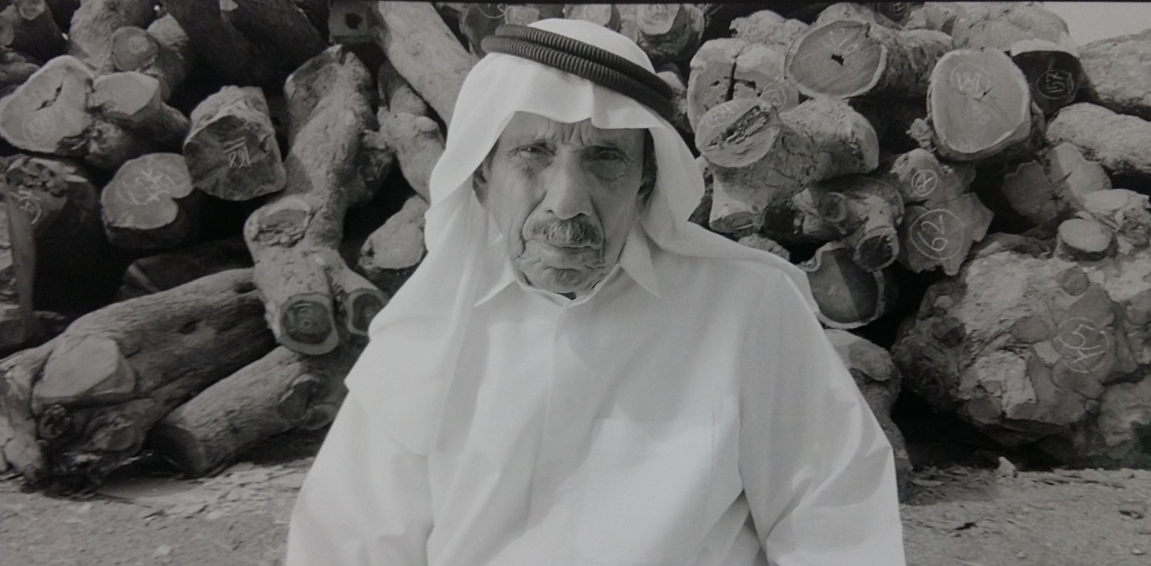

I was born in Umm Hurair, Dubai in about 1928. My father worked as a dhow carpenter. He died when I was nine or ten years old and afterwards I started the same job. I had five sisters, no brothers. I was the youngest, but I was the only man. In those days, we boys went to learn the Koran in the morning and evening, but after my father died no one had the money to pay for school so I left.
In the summer I went pearl diving. Over the years I did all the jobs on the dive. I started as a boy and I used to fetch things-water, dates and food. Next, I started opening the shells and then I was a saib –the man who pulled up the rope. Then I became a diver. We were young boys and healthy – we were happy, but the captains were very strong and strict. At that time if you didn’t go diving you would have no money - there was no other work. This money was for food for my family. My father had died so there was no other choice.
The water was 12 to 14 meters deep. We had a peg to close our nose and a weight on our feet of maybe eight to ten kilograms made from Zinc which came from India. The weight took us down quickly .When we needed to come up we tugged on the rope and the saib pulled us up.
The year was split into two sections. Part of the year was spent diving, the rest, when the water was cooler, people would go travelling for trade. They would go to Iraq to load the dates in Basra, then to India to unload them, then from India to Africa to take more things. Then they would come back for a few days or a few weeks before starting again. This was the life.
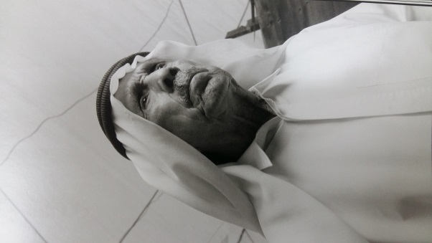
In the winter I worked as a carpenter repairing the dhows for the dhows for the pearling, fishing and trading people .The workshop was in Al Ras. To get there I rowed my own small boat from Umm Hurair to Bur Deira .Then I left it on the sand and walked to Al Ras . Back then, all the families in Dubai had Dhows, big, medium or small,and people got their food from the sea. My cousin, Musabah, started to teach me how to be a dhow carpenter and later I slowly taught myself how to built a the boats.
I was so happy when the hard work of diving had finished for the year and I started my carpentry. It meant in the evenings I would be in the town. I would be able to enjoy the weddings and the dancing parties. In the middle of the sea there was no chance for this.
We built new boats, repaired older boats, checked nails, changed the keels and put cotton in the space between the wood. At that time we worked by the day. Every day I got one rupee-it was very little money. My cousin was happy because he had a healthy boy to help him.
Each lunchtime the owner of the boat would bring us food, usually from his house ,and each evening he would bring us our wage .
For most of the boats we used teak wood outside and qarat inside .The teak came from India, but there were merchants in Dubai who sold it .You could go to the man who had the teak wood and he trusted you . You took the wood and when the owner of the boat paid you, you went back to pay for the wood. The same happened with the nails which we got from the blacksmiths working near Al Ras.
In the 1960s I would go to Oman to buy qarat wood for building dhows. I went to the big gardens there and I would check the trees to see how many bends they had. I was the carpenter so I chose the wood. I knew which piece would go on the front and which piece would go on the back or down the side. I could look at the trees and see that –the design was in my head. I would tell the people where to cut so that we didn’t lose a single foot. I would stay in Oman for two months and after cutting these trees we would bring them back overland on Bedford trucks. Before, there were no roads between here and Oman –it was just sand so it was not easy to drive. It was so hot as there was no air conditioning in the trucks, so we would wear only our underwear when we were driving, no Kandoura. We moved our boatyard up the creek as the city grew. We started in Al Ras, but we had to move near to Dubai Municipality, then Umm Hurair and later Jaddaf.
The first bigger boat I built was called ‘Matara’. Matar means rain and Matara is a woman’s name. I named it that because it was raining at the time we built that dhow.
At this time we worked very hard, but we earned a lot of money .We didn’t sleep, we only worked. It was such a difference to the difficult times before. I built a new house and I married two ladies. Lots of people had lots of money in their pockets. It was a golden time. We thought it would last forever.
Saif was interviewed in 2005 and continues to design and build boats from his own boatyard in Jaddaf on The Creek.

From Telling Tales- An Oral History of Dubai

